**A review on Carbon Nanomaterials fabrication by LASER treatment**

SWAGATA BHATTACHERJEE1, ANANYA BARMAN2, TRINA DUTTA2, KRISHTI DAS3

*1Department of Physics, JIS College of Engineering, Kalyani, Nadia*

*2Department of Chemistry, JIS College of Engineering, Kalyani, Nadia*

*3Department of CSE, JIS College of Engineering, Kalyani, Nadia*

*Corresponding author: ananya.barman@jiscollege.ac.in

**Abstract:** In today's era nanoparticles are mostly used in different fields like electronics, biomedical, environmental and optical due to their unique electrical, chemical and mechanical properties. There was a variety of synthetic methods were used to produce nanomaterials for which the size and shape can be controlled. Among all the synthetic methods, the laser-induced method is one of the effective methods for synthesizing nanomaterials, carbon nanomaterials, hetero atom doped carbon nanomaterials and some novel carbon nanocomposite materials. The laser-induced method is quick, scalable and cost-effective. In this paper, the different laser techniques used for nanofabrication and the production of different carbon nanomaterials are summarised.

**Keywords:** Laser-Induced Method, Micro and Nanofabrication, Laser Cladding, Laser Melting, Graphene, Hetero-doped Carbon Nano Materials.

1. **Introduction:**

Nanomaterials previously known as “Magic Bullets” [1] manifest a number of unique properties for various applications, such as nanoscale electronics [2]; energy storage & its conversion [1]; sensors & actuators [3]; photonics devices [4]; also in the biomedical field [5].

Although nano materials can be fabricated by different techniques, the uniform and bulk production of nano materials is still under research. With the recent technological advancement in laser technology, a new pathway of nanomaterial synthesis has been opened. The laser technique can be conducted in any environment irrespective of solid, liquid and gaseous medium. It has advantages over other techniques because of its quick, scalable, cost-effective, and environment-friendly in situ processing [6, 7]. In the processing of Nanoscale materials, additional selectivity and unique properties can be obtained by regulating different laser characteristics like intensity, wavelength, frequency, focal length, and pulse width [8, 10]. All these also depend on the photo-thermo-physical properties of the parent materials.

Compared to traditional techniques, the synthetic process of laser synthesis does not involve toxic reagents. Various toxic chemicals are frequently applied in the wet chemical process which is one of the conventional methods capable of producing nanomaterials with unique morphologies. Thermal treatment or annealing is another traditional process conducted in the gas medium in the furnace. But this technique is time-consuming; and even not suitable for heat-sensitive materials. Moreover, energy is lost in this process for not being an area-specific technique. On the contrary, in laser synthesis, the focused irradiation beam of the laser creates site-specific growth. It also conducts fast, direct, non-contact 3D-compatible stereo chemically confined reactions [9]. Additionally, as a micro-fabrication technique, the laser is focused precisely on specific positions as necessary and creates patterns locally not altering the adjacent area [11, 12]. Overall, laser technology not only provides a favorable substitute for conventional synthesis processes but also innovates selective area-specific synthesis and micro-fabrication strategies. In the 21st century, enormous carbon-based nanomaterials are being fabricated with advanced diverse laser technologies. Also, the synthesized novel materials are established as highly promising materials for multidisciplinary research work. A few of these are diamond-like carbon; glassy carbon; heteroatom-doped carbon and graphene material. In this study, the researchers will discuss fabrication techniques of different nanomaterials by laser synthesis and analyze their properties with the application.

1. **Application of Laser in Micro and Nanofabrication**

Due to the high directionality laser has become an efficient tool for accurate focusing. It can create and design a pattern in desired locations with almost no distressing of the surroundings [13]. Micro-fabrication is involved with simultaneous synthesis and pattern generation with laser processing. The laser micro-fabrication method is advantageous in cost reduction, high production and reliability. Thus it is cost-effective and beneficial and has a huge application in micro and nanostructure fabrication with a high degree of precision. In this section, some popular micro-fabrication techniques are discussed.

* 1. **Laser cladding:**

LASER surface treatment is a useful technique for the modification of structure as well as the incorporation of metallurgical effects. One of these is laser cladding, which is fundamentally a technique where a laser beam is applied to blend the chosen material on a substrate [14]. This process requires a powerful laser beam for melting and deposition of the feeding material with a high degree of precision and low dilution. Thus the deposited layer suffers from negligible mixing with the substrate, resulting in less distortion, high bonding strength and improved mechanical properties of the deposited layer. LC technique has also a strong potential in mixing different components with a controlled feeding rate due to which it is extensively used for the fabrication of heterogeneous components as well as graded layers. The capability of strong localized fusion and deposition made this technique a useful tool for nanofabrication. Due to fast cooling and solidification, excellent micro-hardness is also found in laser-aided crystallizations. Since laser power, scanning rate and power feed rates are also equally important and play a key role in the formation of the deposition layer it does not apply to all kinds of surface treatment [15].

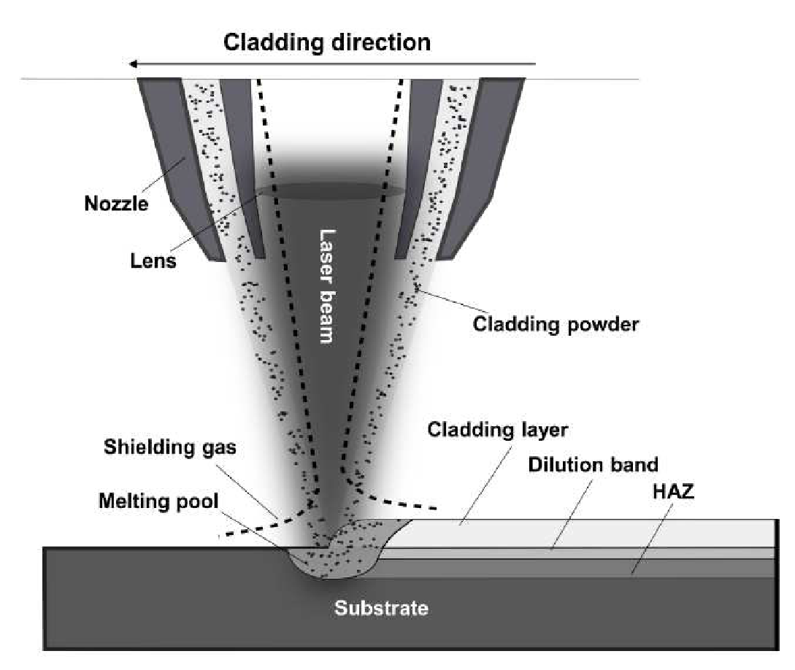

FIGURE 1. Schematic diagram of LC technique [16]

Fig. (1) represents a LC technique [16] where cladding powder is blowing in the laser beam which incidents on the substrate for fusion and formation of the clad layer. In [15], the impacts of the directionality of the cladding layer were studied. Also, the effects of pre-heating and post-heating on microstructural and mechanical properties were observed. Two different directions of cladding with heat treatment were implemented. It was found that change in the direction of cladding as well as pre/post-heating parameters of the repair has a significant role in the microstructural and mechanical properties of the cladding rails. In [17] CO2 LC was implemented for the deposition of Ni-based mixed alloy powder on low-carbon steel and its effects on microstructure and hardness were investigated. [18] dealt with the optimization of performance indicators of LC technique and its impacts on the microstructures were observed. Their observations established the fact that laser power of 1,000 W with 0.5 gm/min powder feed rate and 800 mm/min scan rate can be utilized in order to obtain optimal results for Tenon repairing on a steam turbine blade. Another notable factor examined is the dilution rate, which impacts a lot on the properties of the cladding layer. In [19], a multi-layered ceramic composite coating is fabricated of aluminium oxide, titanium di-boride and titanium carbide. They studied the dependence of laser scanning rate on micro-hardness and phase composition of the cladding. It was observed that an increase in the scanning rate enhanced the hardness but at the same time, an opposite trend was followed for the grain size. The maximum speed of laser scanning was applied as 10 mm/s for synthesis to obtain the basic component of nano-fibers. LC Technology was applied to synthesize the nanoscale quasicrystals, amorphous and ultrathin hard composites [20] using Ni60A-TiC-NbC-Sb mixed powders on the AM TA1 titanium alloy. A detailed investigation is performed to study the physical properties and microstructure formation of the coated layers and excellent hardness was unveiled by the composites. The produced NiSb polycrystals cultivated along (101), (110), (102) and (201) planes. Again, the nano scale I-phase with five-fold symmetry was found in the same.

* 1. **Selective laser melting**

Selective laser melting (SLM) is a type of additive manufacturing that has attracted considerable attention due to its capacity of producing complex geometry. In this method, a thin coating of powder is uniformly distributed over a building podium and a high-power laser beam is utilized for the melting of powdered material. A liquid pool is formed that solidifies and cools rapidly. After scanning the cross-sectional area, the building platform is reduced

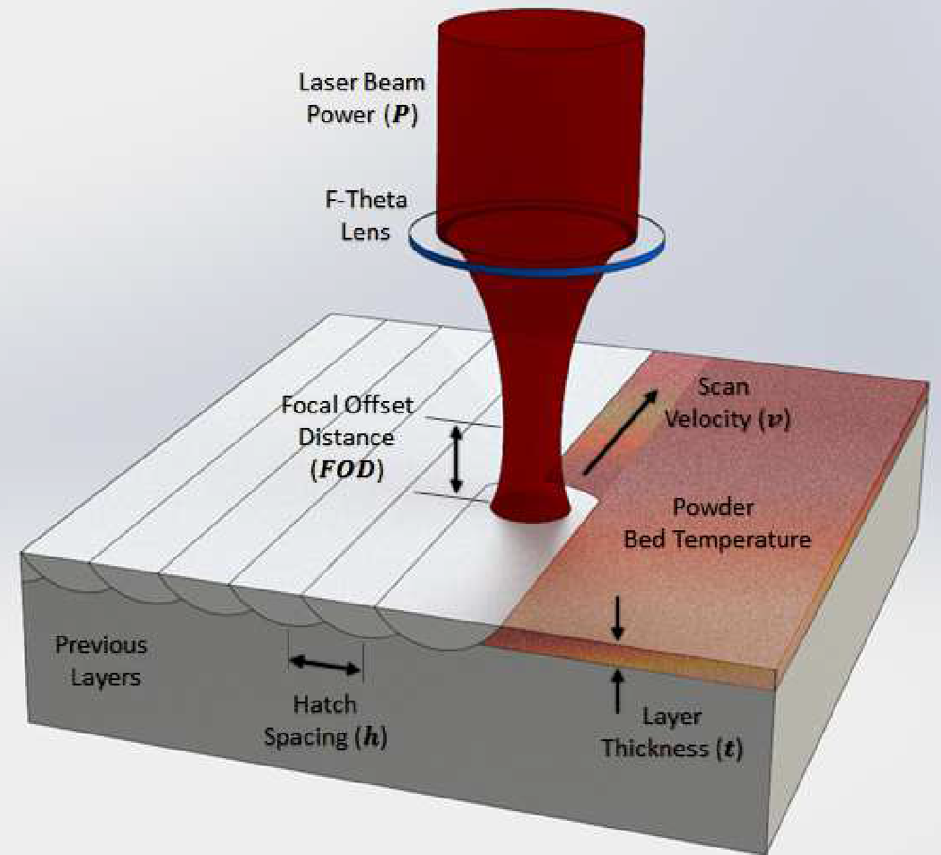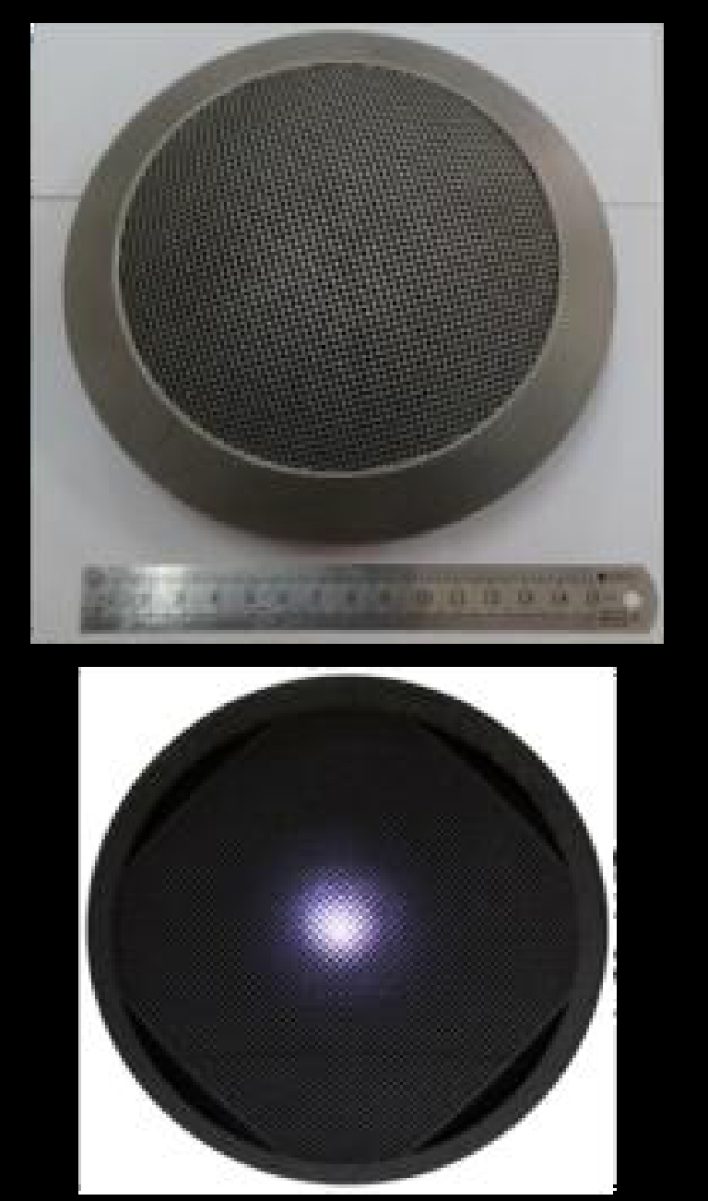

FIGURE2: Schematic diagram of SLM technique [ 21] & the generated pattern [ 22]

appropriately. After completion of the starting layer, the deposition and scanning are followed for the next one. Thus a well-bonded three-dimensional structure is fabricated using a layer-by-layer deposition technique, with high density on a CAD file [23]. SLM is used to simulate a wide range of components of different types of materials like metals, ceramics and polymers without post-processing. Fig. (2) demonstrates the SLM technique [21], whereas Fig. () represents its application in the formation of lobster-eye structure [22]. In [22], a lobster-eye-like thin wall structure is fabricated with AlSi10Mg powder following SLM and the impacts of laser power on the material properties like surface roughness, defect density, and densification capacity of the said structure were investigated. Hence optimal laser power was determined for the deployment of the structure. [24] Reported the fabrication and control of the martensites in the TC4 alloy by applying SLM. The investigations revealed that the martensitic sizes inflamed with the increase of scanning rate from 600 to 1100 mm/s. Hence, quasi-nano-size martensitic can be shaped by altering the SLM handling parameters. While implementing SLM, the role of laser power on the grain morphology and crystallographic texture of AlSi10Mg alloy is studied in [25]. It was seen that using the high power of the laser, a thinner grain can be received. Again three types of zones were found in the microstructures due to the formation of different temperature zones at the heating of the laser beam. Fine zones were formed when the temperature is higher than the liquid’s temperature whereas coarse zones were developed when the temperature is intermediate between liquids and solidus temperatures. But when the temperature is lower than the solidus temperature, the development of Si particles was found. In [26] the densification of nano-TiC armored Inconel 718 composites was studied by the SLM approach and the microstructural, as well as mechanical properties of the nanocomposites, were investigated. A high density of 96.74% was found for a laser energy density of 300 J/m, attributed to an excellent metallurgical bonding among the surrounding layers. The other mechanical parameters like nano hardness and modulus of elasticity were also improved a lot by applying high-density laser energy. Again, a low friction coefficient was obtained for the same energy laser and the most interesting fact is that a change of wear mechanism was noticed from adhesive to abrasive wear for the same. And finally, a superior TiC/ Inconel 718 with a spinning and suspended blade of 1mm width was successfully fabricated implementing SLM under the optimum condition of processing inputs.

* 1. **Laser shock peening**

Laser shock processing (LSP) is an emerging technology used for the surface enrichment of metal alloys. It was first investigated in the USA by Fair and Clauer [ 27] around 35 years back and developed for the up gradation of resistance to fatigue cracking [28] in the aeronautic industry. In this method, a high energy short nanosecond laser pulse is produced with high repetition rates, which are allowed to fall on the sample underwater. Plasma is

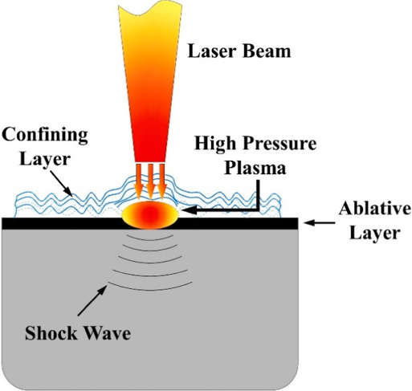

FIGURE 3. Schematic diagram of LSP technique [33]

generated during the contact time of laser light and as a result of which high-level shock waves are generated and a deep residual compressive stress is developed into the material surface [ 29]. LSP is effectively applied to improve the strength, hardness, corrosion and fatigue fracture resistance [30, 31] of materials like chromium, aluminium, nickel, titanium alloy and also for stainless steel. Another advantage of LPS is the refinement of grains which recovers the weariness of the material [27, 32]. Again LSP is also applied to develop different complex shapes by accurate adjustment of the position and spot size of the laser. Fig. (3) demonstrates the LSP technique [33]. In [34] the impacts of nano crystallization on the corrosion behaviour were studied for AZ91D magnesium alloy. In this report, it was observed that laser energy played a crucial role in the modification of surface topography and roughness. A significant improvement (86.2%) of these parameters was obtained with the laser energy of 5J caused by the grain refinement and dislocation strengthening of the material. [35] Investigated the effects of LSP on microstructural development in absence of coating parameters. They also observed the crystal dislocation associated with the terrific plastic strains. Their observation established that all roughness parameters can be lowered by increasing the laser power density.

1. **Synthesis of Carbon nano particles by Laser Technology:**

Nowadays carbon nano particle plays an important role in the field of environmental application [36-42], electrical field [43-46] and biomedical field [47-51] as it has large surface area compared to the volume, unique shapes reactivity and also its unique optical property [52]. Carbon nano particles are also used to increase the mechanical strength and the thermal conductivity of a material [53-55]. There are different kinds of carbon nano materials are available like graphene, fullerene, carbon nano tube etc. Heating or annealing is the general method to synthesize carbon nano materials, which demand high temperatures. Thus a huge amount of energy is lost during the synthesis. Laser technology can be used as an alternative solution for this issue and can be used for the synthesis of different graphene-based materials, diamond-shaped carbon nano particles and different carbon-doped compounds.

**2.1. Graphene synthesis with laser technology:**

The precursors like SiC, some polymers and graphene oxides (GO) were used in laser technology for the synthesis of Graphene. In many research work the graphene oxides were reduced chemically by using a reductant [56], thermally with high temperature [57], or using light irradiation [58]. But laser synthesis of graphene oxides is the most effective method and provides localized reduction and controlled pattern comparative all these methods [59]. The high quality and resistance to ultra-low sheet, graphene structures can be produced by using laser technology [60]. In this process, the formed reduced graphene oxides (rGO) show high conductivity due to the healing of structural defects with the help of high temperature (>2500⁰C) used in the laser-induced method. There were different methods applied in various research works to produce graphene-reducing graphene oxide by the laser-induced process. In their research work, Wong, et. al., reduced the graphene oxide by electro-spraying process and after that cut the undesired areas by nano second laser, fig 4 [61]. Another research work by Qu et al., prepared mixed and asymmetry G/GO fibres by using laser, reducing the GO fibre partially. This asymmetric fibre served as an excellent moisture-sensitive material, fig 5 [62]. Thus laser is useful for the controlled reduction of GO.

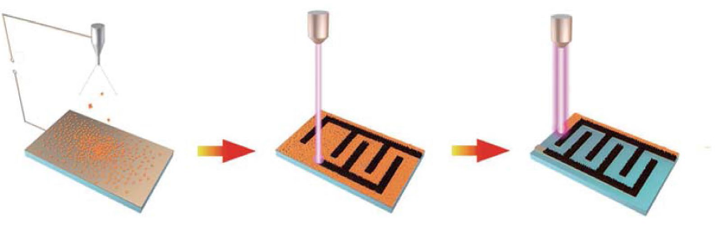

FIGURE 4: Electro Spraying process – Reduction of GO by laser – cutting off undesired area [63]

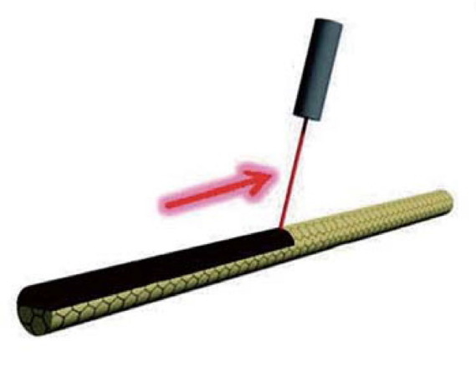

FIGURE 5: Asymmetric synthesis of G/GO fibre by laser [63]

Qu, et. al., further experimented with the laser triggering on highly porous aerogel and within 37.5 ms a 5 cm3 piece of aerogel converted into graphene. In this case, the air trapped in the porous sites helped the sustainable reduction, fig 6. This method is also suitable for the synthesis of graphene-metal or metal-oxide composite materials [64].

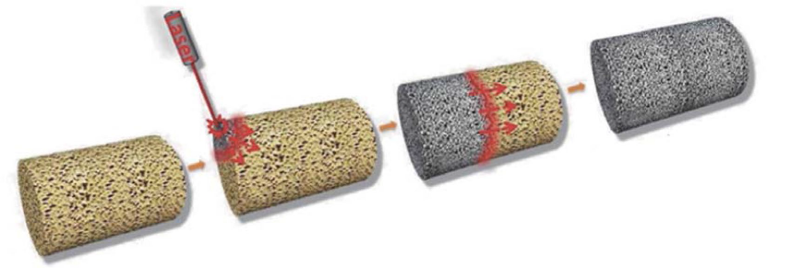

FIGURE 6: Laser triggering on GO and reduction to graphene[63]

Graphene can be synthesized by laser using polymer, like polyimide (PI) as a precursor. In presence of laser irradiation the sp3 carbon atom, present in the polymer, is arranged in a manner of sp2 carbon atom producing the graphene with a large surface area. Tour et. al., in their research work, produced graphene from PI by laser scribing process [65]. Their group confirmed by several experiments that laser-induced graphene (LIG) only can be produced from polyimide and poly(etherimide). During the laser irradiation of the polymer, the lattices vibrated causing a rise in temperature. At this high temperature the bonds between the C-N, C-C and C=O, were broken and the recombination of atoms was taken place. The repeating unit of the polymer, the frequency of the laser used and the exposure time play an important role in the production of graphene in laser-induced process. Their group also introduced the H3BO3 in polyimide matrix producing the b-embedded graphene by laser technology (66). They proved that in this method the polymer is the best choice for the synthesis of 3D and highly porous graphene whereas the CO2 laser radiation (10.6 μm) with high wavelength is preferable. In addition, Lu, et. al., used the direct laser writing method with 532nm wavelength and 5W power on a Ni foil in presence of CH4 and H2 atmosphere [67, 68]. Continuous irradiation controlled the pattern of graphene, in general, the use of carbon vapour deposition and epitaxial growth techniques are used to produce graphene which are expensive and time-consuming. Salleo et al. [69], developed a new technique for synthesizing graphene to solve this problem. In their research work, they used single crystal of SiC and pulsed KrF laser of 248nm wavelength. The laser irradiated the surface of SiC for 25ns and decomposition took place fig 7.

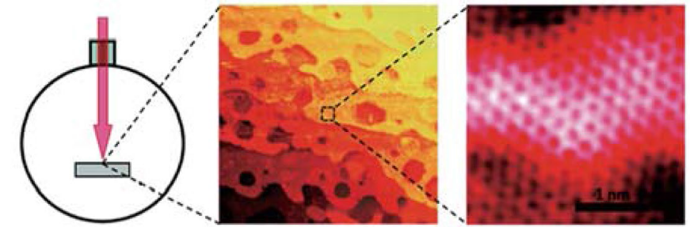

FIGUE 7 : Laser irradiation of SiC face [63]

In another research work of Choi and Lee et al. [70], N-doped graphene was produced by using doped SiC material laser-induced method fig8.

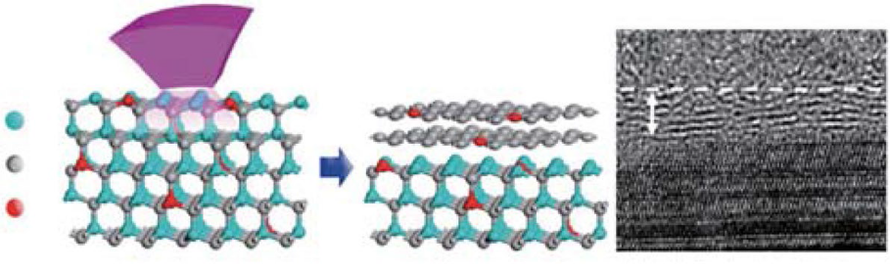

FIGURE 8: N-doped grapheme by laser induced method [63]

**2.2. Synthesis of Diamond-like structures of carbon nanomaterials:**

It was observed in many research works that the carbon nanomaterials which are diamond-like, after combining with graphene, exhibited some unique properties like high conductance and transparency. In the research work of Stock et al. [71], diamond-like carbon DLC nanofilm was produced by using the laser-induced method on graphite in a vacuum chamber at 10-8m bar pressure. After that, a graphene film was placed on the DLC by annealing the surface of DlC with UV laser as indicated in fig 9. There were different hydrocarbons used in the work of Fan et al. [72], as precursors like ethylene, acetylene and oxygen for the formation of DLC by using UV laser irradiation and a combustion torch. During the growth of nanoparticles, at first, the hydrocarbon radicles attached to the active sites and then the hydrogens were abstracted to create more active sites to accept the hydrocarbons. These reactive species played an important role in the growth of diamond-like carbon nanoparticles.

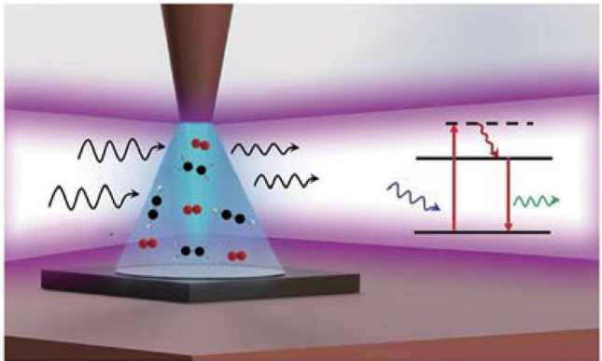

FIGURE 9: UV laser-induced DLC synthesis [63]

**2.3.Carbon nanoparticles doped with Hetero atom:**

It was already mentioned in this paper that Tour, et. al., prepared graphene doped with Boron by using H3BO3 [66]. Furthermore Alshareef et al. [73], doped graphene with nitrogen atoms where polyimide containing urea was used as starting material in the Copper foil. In this method, sodium-ion batteries can be fabricated without the use of an additional binder or any additives by using a laser-induced method. In another research work, Li et al. [74], used polybenzimidazole (PBI) to produce an S or N- doped graphene pattern on the substrates like polyethylene terephthalate (PET) and glass with the help of UV laser of 355 nm wavelength. Again Boron or nitrogen-doped nano horns of carbon can also be produced by using CO2 laser beam in a nitrogen atmosphere [75]. Fluoro polymer, (Ruoff et al.) [76] with the help of Ramon laser of 488 nm wavelength produced the fluorine-doped graphene. During the use of laser, the produced active fluorine radicles formed the bond with the sp2carbon atom. Thus the use of hetero-atom as the precursor, doping is possible with carbon nanomaterials by using a laser-induced process and the production of doped nanoparticles can be controlled by the frequency, power, or pulse width.

Nowadays carbon nanotubes grip great attention for their high strength, unique conductance and chemical heat resistance [77-79]. CNT can be produced by the laser ablation method [80].

**2.4. Synthesis of novel materials:**

There were many novel nanomaterials were synthesized for application in the environmental field. Similarly, a novel material ZnS/ Au/f multi-walled carbon nanotubes (MWCNT) were developed by Naik, et. al. [81] which was able to detect nitro phenol-like toxic pollutants. Pure ZnS was synthesized with the help of pulsed laser irradiation in the presence of di methyle sulphoxide. After that, the gold nanoparticles were dispersed on the ZnS surface by the laser-induced method. Further, ZnS/Au nanocomposites were added to the MWCNT in a chemical route to form ZnS/Au/f-MWCNT. XRD diffraction analysis of this nanocomposite material showed the co-existence of ZnS Au nanoparticles in the MCNT structure. In Ramon spectra, there were two unique peaks at 1584 cm-1 and 1332 cm-1 observed for the nanocomposites confirming the formation of ZnS/Au/f-MWCNT. UV-VIS spectra showed an intense peak at 267 nm due to the electronic transition of π – π*. Thus ZnS/ Au/ f- MWCNT composites can be formed by using the laser-induced method and are applicable as electrochemical sensors [81].

1. **Conclusion:**

The Laser-induced method is useful for the synthesis of nanomaterials and the shape, size and pattern of nanomaterials can be controlled by the frequency, intensity and duration of laser irradiation on the precursor. The use of a laser of a specific wavelength depends on the absorption property of the precursor used for the synthesis of nanomaterials. The laser-induced method is more advantageous as it is fast and less energy is lost during the process. This method is also compatible with a wide range of materials for the synthesis of nanoparticles. But still, some limitations are there for the laser-induced method like it is difficult to synthesize 3D nanoparticles by this method. In the future, this laser-induced method will be developed more for the production of different nanomaterials.

**Reference:**

[1] Patel J.K., Patel A. and Bhatia D. Introduction to Nanomaterials and Nanotechnology. In: Patel, J.K., Pathak, Y.V. (eds) Emerging Technologies for Nanoparticle Manufacturing. Springer, (2021). Cham.

[2] Kim T.S., Lee Y., Xu W., Kim Y.H., Kim M. et al., Direct printed nanoscale metal-oxide-wire electronics. *Nano Energy* **58** (2019) 437–446.

[3] Wang H., Tran D., Qian J, Ding F., Losic D, MoS2/graphene composites as promising materials for energy storage and conversion applications. *Adv. Mater. Interface* **6**(20) (2019) 1900915.

[4] Chorsi M.T., Curry E.J., Chorsi H.T., Das R., Baroody J. et al., Piezoelectric biomaterials for sensors and actuators. *Adv. Mater*. **31**(1) (2019) 1802084.

[5] Dong W., Liu H., Behera J.K., Lu L., Ng R.J.H. et al., Wide bandgap phase change material tuned visible photonics. *Adv. Funct. Mater*. **29**(6) (2019), 1806181.

[6] Joe D.J., Kim S., Park J.H., Park D.Y., Lee H.E. et al., Laser–material interactions for flexible applications. *Adv. Mater*. **29**(26) (2017) 1606586.

[7] Bian J., Zhou L., Wan X., Zhu C., Yang B. et al., Laser transfer, printing, and assembly techniques for flexible electronics. *Adv. Electron. Mater*. **5**(7) (2019) 1800900.

[8] Palneedi H., Park J.H., Maurya D., Peddigari M., Hwang G.T. et al., Laser irradiation of metal oxide films and nanostructures:applications and advances. *Adv. Mater*. **30**(14) (2018) 1705148.

[9] Hong S., Lee H., Yeo J., Ko S.H., Digital selective laser methods for nanomaterials: from synthesis to processing. *Nano Today* **11**(5) (2016), 547–564.

[10] Sapra N.V., Yang K.Y., Vercruysse D., Leedle K.J., Black D.S. et al., On-chip integrated laser-driven particle accelerator. *Science* **367**(6473) 79 (2020).

[11] Yang C., Huang Y., Cheng H., Jiang L., Qu L., Rollable, stretchable, and reconfigurable graphene hygroelectric generators. *Adv. Mater*. **31**(2) (2019), 1805705.

[12] Penilla E.H., Devia-Cruz L.F., Wieg A.T., Martinez-Torres P., Cuando-Espitia N. et al., Ultrafast laser welding of ceramics. *Science* **365**(6455) (2019) 803.

[13] Zhiyun Y., Molin S., Jianing L. Cainian J., Shubo X., Liqiang L., Guocheng R. and

Xiaolin W. Laser nano-technology of light materials: Precision and opportunity. *Optics*

*and Laser Technology* 139 (2021) 106988.

[14] Yellup J.M. Laser cladding using the power blowing technique. *Surface and coating*

*technology* 71(1995)121-128.

[15] Zhan X.H., Peng Q.Y., Wei Y.H. and Ou W.M. Experimental and simulation study on

the microstructure of TA15 titanium alloy laser beam welded joints. *Opt. Laser*

*Technol*. 94 (2017) 279–289.

[16] Lai Q., Abrahams R., Yan W., Qiu C., Mutton P., Paradowskac A. and Soodid M.

Investigation of a novel functionally graded material for the repair of premium

hypereutectoid rails using laser cladding technology. *Compos. Part B: Eng* 130 (2017) 174–191.

[17] Zhang S.H., Li M.X., Cho T.Y., Yoon J.H., Lee C.G. and He Y.Z. Laser clad Ni-base

alloy added nano- and micron-size CeO2 composites. *Opt. Laser Technol*. 40 (2008)

716–722.

[18] Lin C.M. Parameter optimization of laser cladding process and resulting microstructure

for the repair of tenon on steam turbine blade. *Vacuum*. 115 (2015) 117–123.

[19] Masanta M., Ganesh P., Kaul R., Nath A.K. and Choudhury A.R. Development of a

hard nano-structured multi-component ceramic coating by laser cladding*. Mater. Sci. Eng: A.* 508 (2009) 134–140.

[20] Li J.N., et al. Microstructures evolution and physical properties of laser induced NbC modified nanocrystalline composites. *Physica E.* 94 (2017) 1–6.

[21] Shipley H., McDonnell D., Culleton M., Coull R., Lupoi R., Donnell G. O’ and Trimble

D. Optimisation of process parameters to address fundamental challenges during selective laser melting of Ti-6Al-4V: A review, *Int. J. Mach. Tool. Manuf.* 128 (2018) 1–20.

[22] Lin K.J., Yuan L.H. and Gu D.D. Influence of laser parameters and complex structural

features on the bio-inspired complex thin-wall structures fabricated by selective laser melting, *J. Mater. Process Technol*. 267 (2019) 34–43.

[23] Suryawanshi J., Prashanth K.G. and Ramamurty U. Tensile, fracture, and fatigue crack growth properties of a 3D printed maraging steel through selective laser melting, *J. Alloys Compd.* 725 (2017) 355–364.

[24] Yang J.J., Yu H.C., Yin J., Gao M., Wang Z.M. and Zeng X.Y. Formation and control

of martensite in Ti-6Al-4V alloy produced by selective laser melting. *Mater. Des.* 108

(2016) 308–318.

[25] Liu X.H., Zhao C.C., Zhou Z., Shen Z.J. and Liu W. Microstructure of selective laser

melted AlSi10Mg alloy. *Mater. Des.* 107677 (2019).

[26] Gu D.D., Zhang H.M., Dai D.H., Xia M., Hong C.and Poprawe R. Laser additive manufacturing of nano-TiC reinforced Ni-based nanocomposites with tailored microstructure and performance. *Compos. Part B: Eng*. 163 (2019) 585–597.

[27] Fairand B.P. and Clauer A. H. In: Laser-Solid Interactions and Laser Processing, AIP

Conference Proceedings 1978, **50** pp.27-42.

[28] Trdan U., Grum J. and Hill M.R. Generation of residual stresses and improvement of

surface integrity characteristics by laser shock processing. Mater Sci Forum 2011, **681** . 480-485.

[29] Trdan U., Porro J. A. , Ocaña J. L. and Grum J. Laser shock peening without absorbent coating (LSPwC) effect on 3D surface topography and mechanical properties of 6082-T651. *Al alloy. Surf Coat Technol.* 208 (2012) 109-116.

[30] Sanchez-Santana U. et al., Wear and friction of 6061-T6 aluminum alloy treated by laser shock processing. *Wear* 260 (2006) 847–854.

[31] Maawad E., Sano Y., Wagner L., Brokmeier H.G. and Genzel C. Investigation of laser

shock peening effects on residual stress state and fatigue performance of titanium alloys. *Mater. Sci. Eng. A* 536 (2012) 82–91.

[32] Laleh M. and Kargar F. Effect of surface nanocrystallization on the microstructural and corrosion characteristics of AZ91D magnesium alloy. *J. Alloys Compd*. 509 (37) (2011) 9150–9156.

[33] Tan D.Q., Mo J.L., He W.F., Luo J., Zhang Q., Zhu M.H. and Zhou Z.R. Suitability of

laser shock peening to impact-sliding wear in different system stiffnesses. *Surf. Coat. Technol*. 358 (2019) 22–35.

[34] Ren X.D., Huang J.J., Zhou W.F., Xu X.D. and Liu F.F. Surface nano-crystallization of AZ91D magnesium alloy induced by laser shock processing. *Mater. Des.* 86 (2015) 421–426.

[35] Trdan U., Skarba M. and Grum J. Laser shock peening effect on the dislocation transitions and grain refinement of Al-Mg-Si alloy. *Mater. Charact*. 97 (2014) 57–68.

[36] Wang, R.; Chen, D.; Wang, Q.; Ying, Y.; Gao,W.; Xie, L. Recent advances in applications of carbon nanotubes for desalination: A review. *Nanomaterials*, 10 (2020), 1203.

[37] Wu, W.; Shi, Y.; Liu, G.; Fan, X.; Yu, Y. Recent development of graphene oxide based forward osmosis membrane for water treatment: A critical review. *Desalination* 491 (2020) 114452.

[38] Kanao, E.; Kubo, T.; Otsuka, K. Carbon-Based nanomaterials for Separation Media. *Bull. Chem. Soc. Jpn*. 93 (2020) 482–489.

[39] Wu, Q.; Lv, H.; Zhao, L. Applications of carbon nanomaterials in chiral separation. Trends *Anal. Chem*. 129 (2020) 115941.

[40] Pan, X.; Ji, J.; Zhang, N.; Xing, M. Research progress of graphene-based nano materials for the environmental remediation. *Chin. Chem. Lett*. 31 (2020) 1462–1473.

[41] Abd-Elsalam, K.A. Carbon Nanomaterials for Agri-Food and Environmental Applications; Micro and Nanotechnologies; Elsevier Inc.: Amsterdam, The Netherlands, 1 (2020) 2.

[42] Peng, Z.; Liu, X.; Zhang, W.; Zeng, Z.; Liu, Z.; Zhang, C.; Liu, Y. Advances in the application, toxicity and degradation of carbon nano materials in environment: A review. *Environ. Int.* 134 (2020) 105298.

[43] Yamashita, S. Nonlinear optics in carbon nanotube, graphene, and related 2D materials. *APLPhotonics,* 4 (2014) 034301.

[44] Zhao, Q.; Song, W.; Zhao, B.; Yang, B. Spectroscopic studies of the optical properties of carbon dots: Recent advances and future prospects. *Mater. Chem. Front*. 4 (2020) 472–488.

[45] Ghosh, D.; Sarkar, K.; Devi, P.; Kim, K.-H.; Kumar, P. Current and future perspectives of carbon and graphene quantum dots: From synthesis to strategy for building optoelectronic and energy devices. *Renew. Sustain. Energy Rev*. 135 (2021) 110391.

[46] Jariwala, D.; Sangwan, V.K.; Lauhon, L.J.; Marks, T.J.; Hersam, M.C. Carbon nanomaterials for electronics, optoelectronics, photovoltaics, and sensing. *Chem. Soc. Rev*. 42 (2013) 2824–2860.

[47] Zhou, N.; Liu, T.; Wen, B.; Gong, C.; Wei, G.; Su, Z. Recent Advances in the Construction of Flexible Sensors for Biomedical Applications. *Biotechnol. J*. 15 (2020) 2000094.

[48] Li, C.; Wang, Y.; Jiang, H.; Wang, X. Review—Intracellular Sensors Based on Carbonaceous Nanomaterials: A Review. *J. Electrochem. Soc*. 167 (2020) 037540.

[49] Kour, R.; Arya, S.; Young, S.-J.; Gupta, V.; Bandhoria, P.; Khosla, A. Review—Recent Advances in Carbon Nanomaterials as Electrochemical Biosensors. *J. Electrochem. Soc*. 167 (2020) 037555.

[50] Kaur, J.; Gill, G.S.; Jeet, K. Applications of Carbon Nanotubes in Drug Delivery: A Comprehensive Review—Chapter 5. In Characterization and Biology of Nanomaterials for Drug Delivery; Nanoscience and Nanotechnology in Drug Delivery Micro and Nano Technologies; 2019 113–135.

[51] Mendes, R.G.; Bachmatiuk, A.; Büchner, B.; Cuniberti, G.; Rümmeli, M.H. Carbon nanostructures as multi-functional drug delivery platforms. *J. Mater. Chem. B*, 1 (2013) 401–428.

[52] Kreyling,W.G.; Semmler-Behnke, M.; Chaudhry, Q. A complementary definition of nanomaterial. *Nano Today* 5 (2010) 165–168.

[53] Szeluga, U.; Pusz, S.; Kumanek, B.; Olszowska, K.; Kobyliukh, A.; Trzebicka, B. Effect of graphene filler structure on electrical, thermal, mechanical, and fire retardant properties of epoxy-graphene nanocomposites—A review. *Crit. Rev. Sol. Stat. Mater. Sci.* 2019, 1–36.

[54] Frank, G.; Lagoudas, D.C. Characterization of electrical and thermal properties of carbon nanotube/epoxy composites. *Compos. B* 56 (2014) 611–620.

[55] Shin, Y.C.; Novin, E.; Kim, H. Electrical and thermal conductivities of carbon fiber composites with high concentrations of carbon nanotubes. *Int. J. Precis. Eng. Manufac*t. 16 (2015) 465–470.

[56] Silva, K.K.H. De , Huang, H.H. , Joshi, R.K. , Yoshimura, M., Chemical reduction of graphene oxide using green reductants. *Carbon* 119 (2017) 190–199 .

[57] Ye, B. Lee, M., Jeong, B., Kim, J.,. Lee D.H . et al., Partially reduced graphene oxide as a support of Mn–Ce/TiO2 catalyst for selective catalytic reduction of NOx with NH3.*Catal.Today* 328 (2019) 300–306 .

[58] Pan, Z., Hisatomi, T. , Wang, Q., Chen, S., Iwase A., et al., Photoreduced graphene oxide as a conductive binder to improve the water splitting activity of photocatalyst sheets. *Adv. Funct. Mater*. 26 (2016) 7011–7019.

[59] Kumar, R., Singh, R.K. , Singh, D.P. , Joanni, E., Yadav R.M., et al., Laser-assisted synthesis, reduction and micro-patterning of graphene: recent progress and applications. *Coord. Chem. Rev*. 342 (2017) 34–79.

[60] Antonelou, A., Sygellou, L., Vrettos, K., Georgakilas, V., Yannopoulos, S.N., Efficient defect healing and ultralow sheet resistance of laser-assisted reduced graphene oxide at ambient conditions. *Carbon* 139 (2018) 492–499.

[61] Xie, B., Wang, Y., Lai, W., Lin, W., Lin Z., et al., Laser-processed graphene based micro-supercapacitors for ultrathin, rollable, compact and designable energy storage components. *Nano Energy* 26 (2016) 276–285.

[62] Cheng, H. , Liu, J., Zhao, Y., Hu, C., Zhang Z., et al., Graphene fibers with predetermined deformation as moisture-triggered actuators and robots. *Angew. Chem. Int. Ed*. 52 (2013) 10482– 10486.

[63] Zhao, L., Liu, Z., Chen, D., Liu, F., Yang, Z., Li, , Yu, H., Liu1, H., Zhou W., Laser, Synthesis and Micro-fabrication of Micro/ Nanostructured Materials Toward Energy Conversion and Storage, *Nano-Micro Lett.* 13 (2021) 49.

[64] Cheng, H., Ye, M., Zhao, F., Hu, C., Zhao Y., et al., A general and extremely simple remote approach toward grapheme bulks with in situ multifunctionalization. *Adv. Mater*. 28 (2016) 3305–3312.

[65] Lin, J., Peng, Z., Liu, Y., Ruiz-Zepeda, F., Ye R., et al., Laserinduced porous graphene films from commercial polymers. *Nat. Commun*. 5 (2014) 5714.

[66] Peng, Z., Ye, R., Mann, J.A., Zakhidov, D., Li Y., et al., Flexible boron-doped laser-induced graphene micro-supercapacitors. *ACS Nano* 9 (2015) 5868–5875.

[67] Park, J.B., Xiong, W., Gao, Y., Qian, M., Xie Z.Q., et al., Fast growth of graphene patterns by laser direct writing. *Appl. Phys. Lett*. 98 (2011) 123109.

[68] Park, J.B., Xiong, W., Xie, Z.Q., Gao, Y., Qian M., et al., Transparent interconnections formed by rapid single-step fabrication of graphene patterns. *Appl. Phys. Lett*. 99 (2011) 053103.

[69] Lee, S., Toney, M.F., Ko, W., Randel, J.C., Jung H.J., et al., Laser-synthesized epitaxial graphene. *ACS Nano* 4 (2010) 7524–7530.

[70] Choi, I., Jeong, H.Y., Jung, D.Y., Byun, M., Choi C.G., et al.,Laser-induced solid-phase doped graphene. *ACS Nano* 8 (2014) 7671–7677.

[71] Stock, F., Antoni, F., Diebold, L., Chowde Gowda C., et al., UV laser annealing of diamond-like carbon layers obtained by pulsed laser deposition for optical and photovoltaic applications. *Appl. Surf. Sci*. 464 (2019) 562–566.

[72] Fan, L.S., Constantin, L., Li, D.W., Liu, L., Keramatnejad K., et al., Ultraviolet laser photolysis of hydrocarbons for non diamond carbon suppression in chemical vapor deposition of diamond films. *Light-Sci. Appl*. 7 (2018) 17177–17177.

[73] Zhang, F., Alhajji, E., Lei, Y. , Kurra, N., Alshareef, H.N., Highly doped 3D graphene Na-Ion battery anode by laser scribing polyimide films in nitrogen ambient. *Adv. Energy Mater*. 8 (2018) 1800353.

[74] Huang, Y., Zeng, L., Liu, C., Zeng, D., Liu Z., et al., Laser direct writing of heteroatom (N and S)-doped graphene from a polybenzimidazole ink donor on polyethylene terephthalate polymer and glass substrates. *Small* 14 (2018) 1803143.

[75] Yuge, R., Bandow, S., Yudasaka, M., Toyama, K., Iijima S., et al., Boron- and nitrogen-doped single-walled carbon nanohorns with graphite-like thin sheets prepared by CO2 laser ablation method. *Carbon* 111 (2017) 675–680.

[76] Lee, W.H., Suk, J.W. , Chou, H., Lee, J., Hao Y., et al., Selectivearea fluorination of graphene with fluoropolymer and laser irradiation. *Nano Lett*. 12 (2012) 2374–2378.

[77] Wang, J. N., Luo, X. G., Wu, T., Chen , Y., High-strength carbon nanotube fibre-like ribbon with high ductility and high electrical conductivity, *Nat. Commun*. 5 (2014) 3848.

[78] Thamaraiselvan, C,, Lerman, S,, Weinfeld-Cohen, K,, Dosoretza, C, G., Characterization of a support-free carbon nanotube-microporous membrane for water and wastewater filtration, *Sep. Purif. Technol*. 202 (2018) 1–8.

[79] Thamaraiselvan, C,, Ronen, A,, Lerman, S, , Balaish, M,, -Eli, Y. E., Dosoretza, C. G., Low voltage electric potential as a driving force to hinder biofouling in self-supporting carbon nanotube membranes, *Water Res*. 129 (2018) 143–153.

[80] Ihsanullah, S., Carbon nanotube membranes for water purification: Developments, challenges, and prospects for the future, *Purif. Technol*. 209 (2019) 307–337.

[81] Naik , S. S., Lee , S. J. , Theerthagiri , J. , Yu , Y. , Choi , M. Y. , Rapid and highly selective electrochemical sensor based on ZnS/Au-decorated f-multi-walled carbon nanotube nano composites produced via pulsed laser technique for detection of toxic nitro compounds, *Journal of Hazardous Materials*, 418 (2021) 126269.